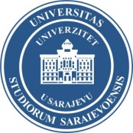 | 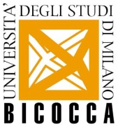  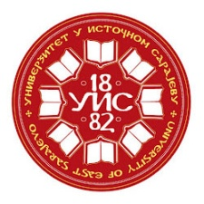 | 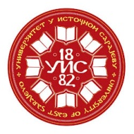

University of Milan-Bicocca, University of East Sarajevo
and University of Sarajevo

International Summer School
Rethinking the Culture of Tolerance
The New Challenges of the European Integration
Sarajevo, 15-21 September 2014

Professors and Directors:
Tatjana Sekulić, Dejan Bokonjić and Ugo Vlaisavljević

Application form for Students
Personal Details
Name and Surname _____________________________________________________________________
Date of birth____________________________________________________________________________
Place of birth ___________________________________________________________________________
Nationality _____________________________________________________________________________

Contact information
Address________________________________________________________________________________
Mobile Phone___________________________________________________________________________
E-mail _________________________________________________________________________________

Current Education Level:
Course/ Degree ________________________________________________________________________
Department ___________________________________________________________________________
University _____________________________________________________________________________

Information about the Seminar
Who informed you about the Seminar?_______________________________________________________

Documents to be included
- Curriculum Vitae (CV)
- University Record (academic transcript)
- Essay on why you want to attend to the Seminar (max 300 words)

__________________________
Signature of the candidate
The Application Form has to be sent till 5 July 2014
to the following e-mail address: summerschool.tolerance@gmail.com

